**PIZZA SALES SQL QUERIES**

**A.KPI’s**

1. Total Revenue :

select SUM(total_price) as Total_Revenue from pizza_sales



2. Average order value :

select SUM(total_price)/COUNT(distinct order_id) as Average_order_value from pizza_sales



3.Total pizzas sold :

select SUM(quantity) as Total_pizzas_sold from pizza_sales



4.Total orders :

select count(distinct order_id) as Total_orders from pizza_sales



5. Average pizzas order per order :

select cast(cast(SUM(quantity)as decimal (10,2)) /

cast(count(distinct order_id) as decimal (10,2)) as decimal (10,2)) as Average_Pizzas_sold_per_order from pizza_sales



**B.CHART REQUIREMENT ‘S**

1.Daily trend of total orders :

select datename(DW,order_date) as order_day, COUNT(distinct order_id) as Total_orders from pizza_sales

Group by datename(DW,order_date)

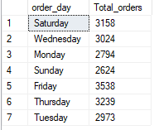

2. Hourly Trends or orders

select DATEPART(hour, order_time) as order_hour, COUNT(distinct order_id) as Total_orders from pizza_sales

group by DATEPART(hour, order_time)

order by DATEPART(hour, order_time)

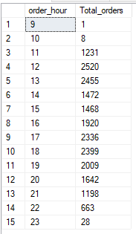

3. Percentage of sales by pizza category

select pizza_category, sum(total_price) *100/ (select SUM(total_price) from pizza_sales)

as Percentage_of_sale_by_category

from pizza_sales

Group by pizza_category

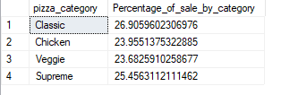

4. Percentage of sales by pizza size

select pizza_size,SUM(total_price) as total_sales, cast(sum(total_price) *100/ (select SUM(total_price) from pizza_sales)

as decimal (10,2)) as Percentage_of_sale_by_size

from pizza_sales

Group by pizza_size

order by Percentage_of_sale_by_size desc

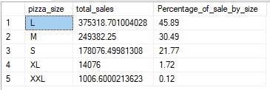

5. total pizza sold by Category

select pizza_category, sum(quantity) as pizza_sold_by_category from pizza_sales

Group by pizza_category

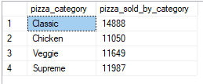

6. Top 5 best seller by total pizza sold

select TOP 5 pizza_name, SUM(quantity) as total_pizza_sold

from pizza_sales

group by pizza_name

order by total_pizza_sold desc

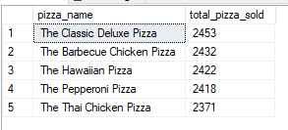

7. bottom 5 worst seller by total pizza sold

select TOP 5 pizza_name, SUM(quantity) as total_pizza_sold

from pizza_sales

group by pizza_name

order by total_pizza_sold

